**Chatbot Using Artificial Intelligence**

**CSCE 5222 Feature Engineering**

**Leela Varadatta Sai Addanki (11617487)**

**Sai Karthik Poojari (11518167)**

**Introduction:**

Artificial intelligence chatbots are chatbots that have been trained to conduct conversations that resemble those of a human using a method called natural language processing (NLP). NLP enables the AI chatbot to comprehend written human language, allowing them to function mostly independently.

In other words, AI chatbot software can comprehend language other than pre-programmed commands and responses depending on the information already in the system. This enables users to take the initiative and express their intentions in their own terms.



**Related Work:**

Most of the time, obtaining all the data on a single interface is hard without the hassle of navigating through several forms and windows. By offering a standard and user-friendly interface to address questions from college students and professors, the chatbot for colleges attempts to eliminate this challenge.

A chatbot system's goal is to mimic a human conversation. Its design combines a computational algorithm and language model to simulate online information exchange between a human and a machine using natural language.

Today, artificial intelligence research is arguably the most fascinating and difficult area of study. It has already demonstrated its ability to resolve some of humanity's most pressing issues. Artificial intelligence (AI) will soon take up more space and be integrated into our daily lives. However, it is necessary to constantly seek out fresh suggestions for improvement and to advance already planned research. Then, as human intellect is prone to error, we will look forward to using intelligent systems to solve such difficulties. The study presented a different theoretical framework for machine intelligence. The initial research may be expanded upon to create cutting-edge AI theories and systems.

**Model Architecture:**

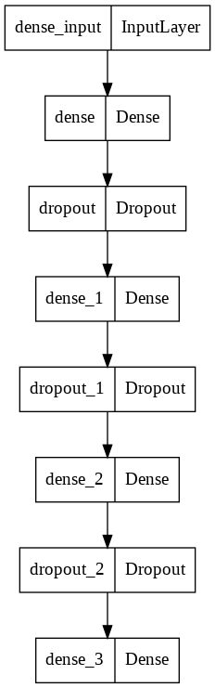

**Dataset Used:**

The dataset used in this model consists of intents. Basically intents is meant by categories of responses or the inputs to the chatbot or the nature of the questions asked by users and the answers given by the chatbot.

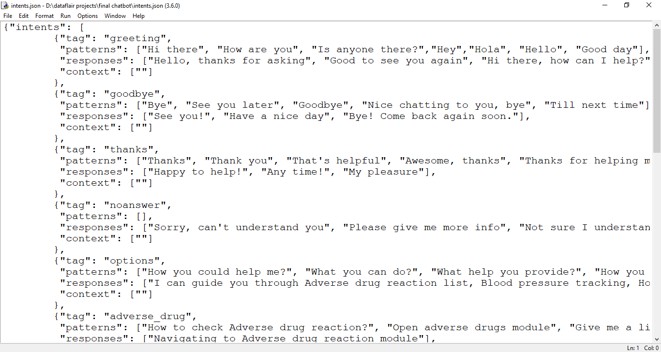

**Graphs:**

These graphs are showing the variations of audio features in graphs. Like the graphs which are showing the speech modulation send to chatbot.

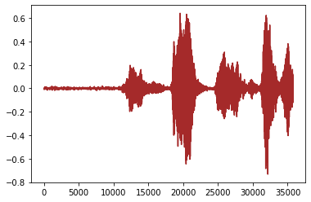

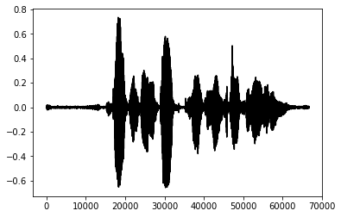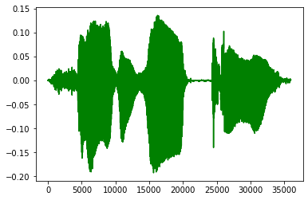

**Data Preprocessing:**

In the data preprocessing part we convert the intents dataset into features because neural networks only understand numbers. We remove stopwords, punctuation and lemmatize the sentences or the words.

**Implementation:**

**Code:**

import json

import nltk

nltk.download('wordnet')

nltk.download('punkt')

nltk.download('omw-1.4')

from nltk.stem import WordNetLemmatizer

import random

import numpy as np

from keras.models import Sequential

from keras.layers import Dense

from keras.layers import Dropout

with open('/content/Intents.json') as file:

data=json.load(file,strict=False)

lemm=WordNetLemmatizer()

words = []

labels = []

X = []

Y = []

for intent in data['intents']:

for text in intent['text']:

w = nltk.word_tokenize(text)

words.append(w)

X.append((w, intent['intent']))

if intent['intent'] not in labels:

labels.append(intent['intent'])

words = [lemm.lemmatize(j.lower()) for i in words for j in i if j not in [' ', '.', '?']]

words=sorted(list(set(words)))

labels=sorted(list(set(labels)))

train=[]

output=[0]*len(labels)

for doc in X:

bag=[]

text = doc[0]

text = [lemm.lemmatize(w.lower()) for w in text]

for w in words:

if w in text:

bag.append(1)

else:

bag.append(0)

output_row=list(output)

output_row[labels.index(doc[1])] = 1

train.append((bag,output_row))

random.shuffle(train)

train=np.array(train)

train_x=list(train[:,0])

train_y=list(train[:,1])

train=np.array(train)

output=np.array(output)

train_x=np.asarray(train_x)

train_y=np.asarray(train_y)

# Model

model = Sequential()

model.add(Dense(64, input_shape=(len(train_x[0]),), activation='relu'))

model.add(Dropout(rate = 0.35))

model.add(Dense(64, activation='relu'))

model.add(Dropout(rate = 0.3))

model.add(Dense(128, activation='relu'))

model.add(Dropout(rate = 0.5))

model.add(Dense(len(train_y[0]), activation="softmax"))

model.compile(optimizer='adam',metrics=['accuracy'],loss='categorical_crossentropy')

model.fit(train_x,train_y,epochs=150,verbose=1,batch_size=3)

model.save('ChatBot.h5')

**Summary of Model:**

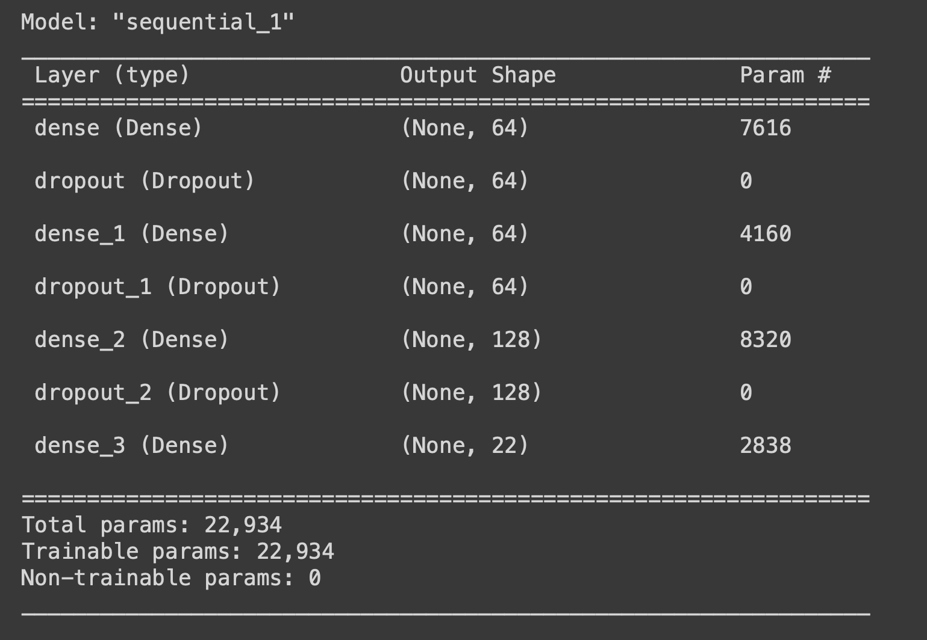

**Steps:**

1. Import and load the data file. Create intents.
2. Preprocess data.
3. Create training and testing data.
4. Build the model.
5. Predict the response (Graphical User Interface).
6. Run the chatbot.

**Implementation status:**

|  |  |  |  |
| --- | --- | --- | --- |
| Responsibility/Task | Description | Contributions(Member/Percentage) | Issues |
| Data Pre-Processing/ PPT | Categerization of each state and visualizing for exploratory data analysis, finding corelations | Sai Leela addanki(60), Karthik Kalyan(20) | Finding perfect corelations between the audio files to categorize. |
| ML Models/ PDF | Activation Functions, Padding Properties, conversion of categorical data are used to build/ test the model | Sai Leela addanki(60), Karthik Kalyan(20) | When running model properties, choosing activation function has been a challenging part. |
| Data Preperation/Gathering/Video | Gathering data from various sources and making them into standard file type and integrating data with tensor flow | Sai Leela addanki(60), Karthik Kalyan(20) | Gathering data from different sources and converting them into a appro[riate file format has been challenging |

**References:**

* Yuhua Li, David McLean, Zuhair A. Bandar, James D. O’Shea, Keeley Crockett, “Sentence Similarity Based on Semantic Nets and Corpus Statistics”, IEEE Transactions on Knowledge and Data Engineering, Volume 18 - No. 8, August 2006. <https://doi.org/10.1109/ICTER.2018.8615462>
* Emanuela Haller, Traian Rebedea, “Designing a Chat-bot that Simulates an Historical Figure”, IEEE Conference Publications, July 2013. <https://doi.org/10.1109/TII.2020.3009277>
* B. A. Shawar and E. Atwell, “Chatbots: are they really useful?”, LDV Forum, vol. 22, no. 1, (2007)
* M. Turing, “Computing Machinery and Intelligence”, Mind, (1950), pp. 433-460.
* Khanna, “Pandorabots Chatbot Hosting Platform. SARANG Bot”, (2015) April 19, Internet: http:// pandorabots.com/pandora/talk?botid=9f0f09a71e34dcf8/.